Name : Shan
Sap : 72387
Sem 2
OOP LAB
Tasks
Functions
- LAB Task 1:

- Q1:Write a program to accept two values from the user and swap them using a third variable.
#include <iostream>
using namespace std;

int main() {
int a, b, temp;

cout << "Enter two numbers: ";
cin >> a >> b;

temp = a;
a = b;
b = temp;
cout << "After swapping: " << a << " " << b << endl;

return 0;
}
Output
Enter two numbers: 4 5
After swapping: 5 4

- Q2:Write a program to accept two values from the user and swap them without using a third variable.
Input
#include <iostream>
using namespace std;

int main() {
int a, b;
cout << "Enter two numbers: ";
cin >> a >> b;
a = a + b;
b = a - b;
a = a - b;
cout << "After swapping: " << a << " " << b << endl;
return 0;
}
Output
Enter two numbers: 9 6
After swapping: 6 9

- Q3:Write a C++ program that get Two Values From User and Perform Mathematical operation using Function.
Input
#include <iostream>
using namespace std;
void CalMath(int n1, int n2) {
cout << "--- Results ---" << endl;
cout << "Addition: " << n1 + n2 << endl;
cout << "Subtraction: " << n1 - n2 << endl;
cout << "Multiplication: " << n1 * n2 << endl;
if (n2 != 0) {
cout << "Division: " << (float)n1 / n2 << endl;
} else {
cout << "Division: Not possible " << endl;
}
}
int main() {
int a, b;
cout << "Enter two numbers: ";
cin >> a >> b;
CalMath(a, b);
return 0;
}
Output
Enter two numbers: 4 5
--- Results ---
Addition: 9
Subtraction: -1
Multiplication: 20
Division: 0.8

- Q4:Write a Program Swap Two Values without using third variable using Function.
Input
#include <iostream>
using namespace std;
void swapNo(int &x, int &y) {
x = x + y;
y = x - y;
x = x - y;
}
int main() {
int a, b;
cout << "Enter value for A: ";
cin >> a;
cout << "Enter value for B: ";
cin >> b;
cout << "Before Swapping: A = " << a << " B = " << b << endl;
swapNo(a, b);
cout << "After Swapping: A = " << a << " B = " << b << endl;
return 0;
}
Output
Enter value for A: 7
Enter value for B: 8
Before Swapping: A = 7 B = 8
After Swapping: A = 8 B = 7

- Q5: Write a Program that get vallue from user and dispay Factorial using Function.
Input
#include <iostream>
using namespace std;
long long calculateFactorial(int n) {
long long fact = 1;
for(int i = 1; i <= n; i++) {
fact = fact * i;
}
return fact;
}
int main() {
int number;
cout << "Enter a positive number: ";
cin >> number;
if (number < 0) {
cout << "Error: Factorial of a negative number does not exist." << endl;
}
else {
cout << "The Factorial of " << number << " is: " << calculateFactorial(number) << endl;
}
return 0;
}
Output
Enter a positive number: 9
The Factorial of 9 is: 362880

Arrays

- LAB Task 2 :

- Q1: Write a Program that Declares an arrays and copies its Even Values Into a New Array and Displays it.
Input
#include <iostream>
using namespace std;
int main()
{
int arr[10], z = 0;
int flag = 0;
cout << "Enter the values : ";
for (int i = 0; i < 10; i++)
{
cin >> arr[i];
}
for (int j = 0; j < 10; j++)
{
if (arr[j] % 2 == 0)
flag++;
}
int arr2[flag];
for (int k = 0; k < 10; k++)
{
if (arr[k] % 2 == 0)
{
arr2[z] = arr[k];
z++;
}
}
for (int y = 0; y < flag; y++)
{
cout << arr2[y];
}
return 0;
}
Output
Enter the values : 1
2
3
4
4
5
6
7
9
8
24468

- LAB Task 3 :

- Q1:Write a C++ program that asks the user to enter the number of rows and columns for a 2D integer array and then inputs all the elements of the matrix from the user. After storing the values, the program should check each element of the 2D array and determine whether it is a odd number or not. The program should count how many odd numbers are present in the matrix.
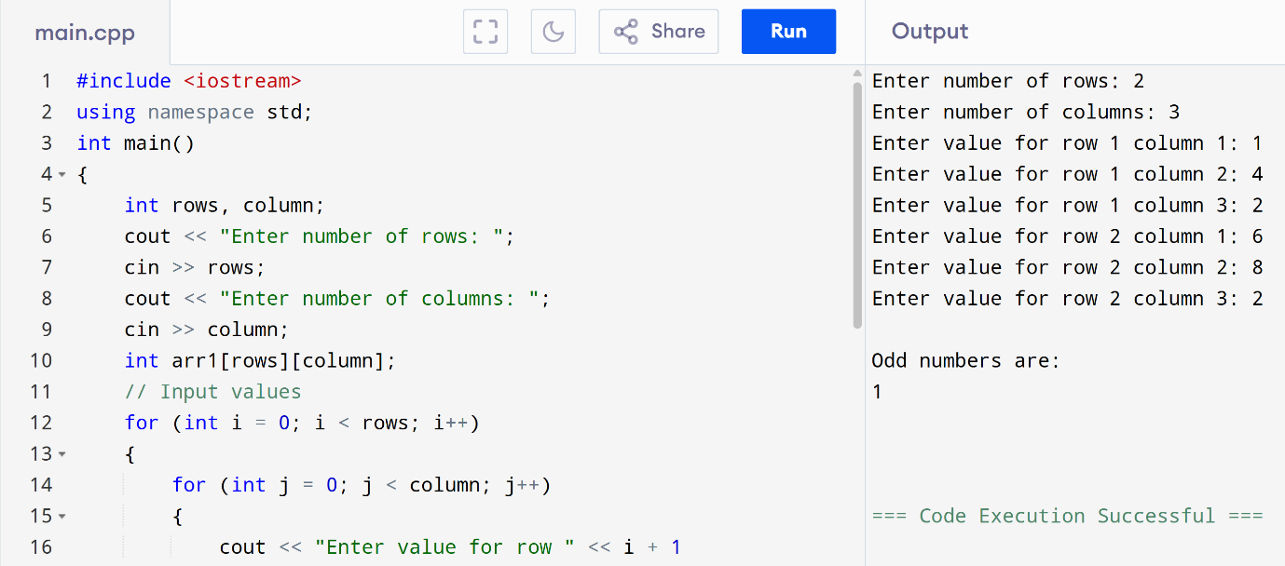
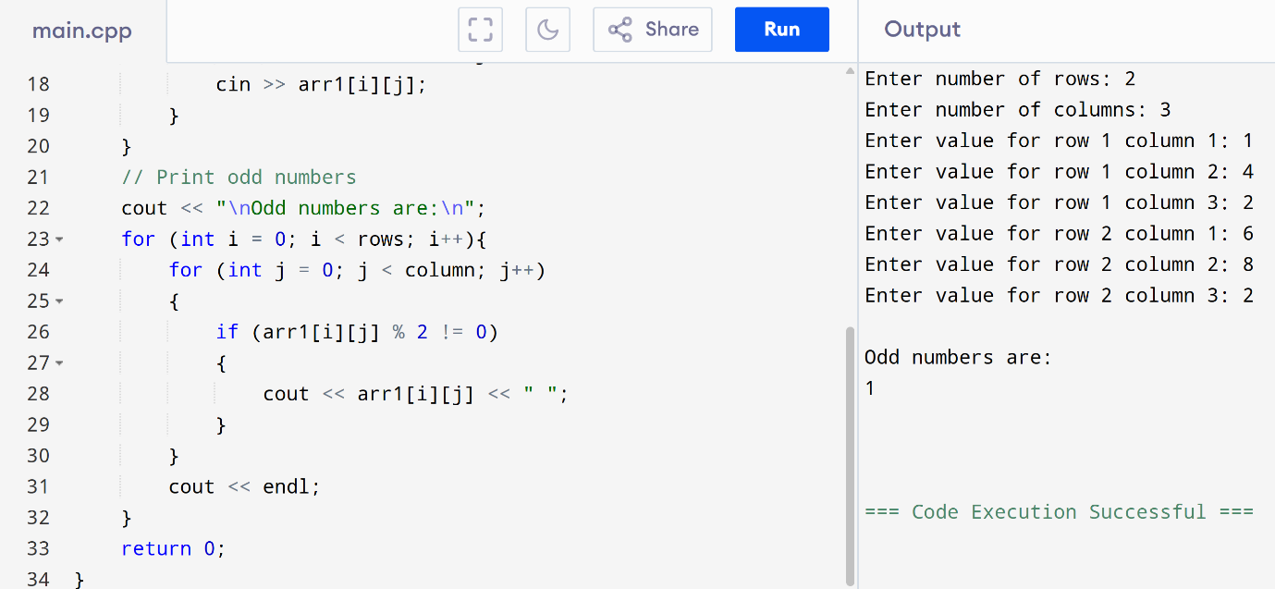

- Q2:Write a C++ program that asks the user to enter the number of rows and columns for a 2D integer array and then inputs all the elements of the matrix from the user. After storing the values, the program should check each element of the 2D array and determine whether it is a prime number or not. The program should count how many prime numbers are present in the matrix and display the total prime.

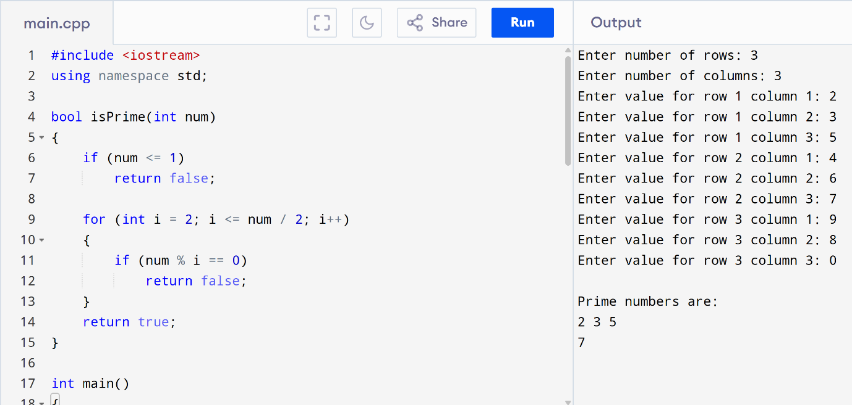
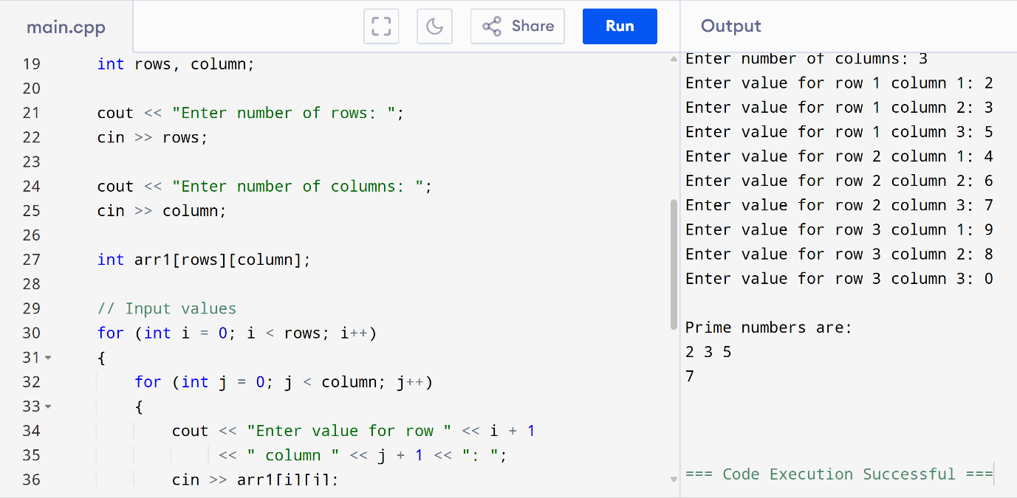

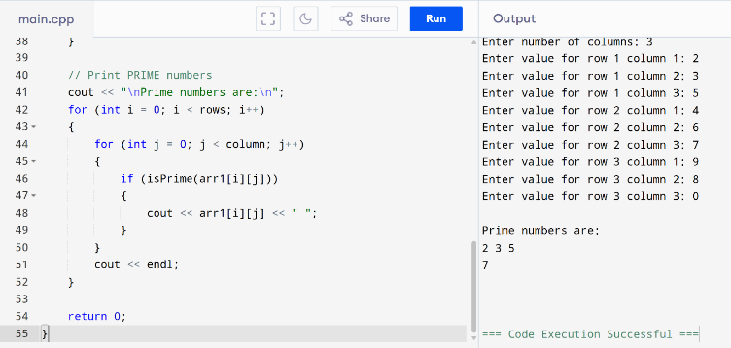

- Q3:Java Program Cal…..
Solution:
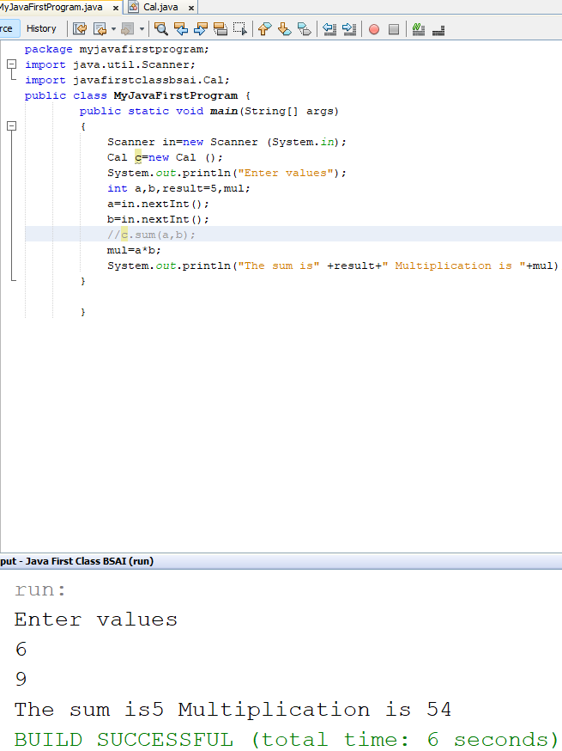
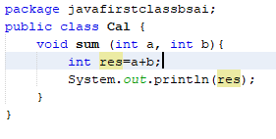

- Lab task # 4
- Question: 1
Write a Java Program to Create a Calculator.
- Input :
Main Class
package com.mycompany.exe;
import java.util.Scanner;
public class Exe {
public static void main(String[] args) {
int a, b, res;
Scanner s = new Scanner(System.in);
System.out.println("Enter values:");
a = s.nextInt();
b = s.nextInt();
Cal1 c1 = new Cal1();
Cal2 c2 = new Cal2();
res = c1.sum(a, b);
System.out.println("The sum of " + a + " and " + b + " is: " + res);
c1.mul(a, b);
System.out.println("Division is: " + c2.div(a, b));
int y = c2.mod(a, b);
System.out.println("Remainder is " + y);
}
}

Class 2
Class 1
package com.mycompany.exe;
import java.util.Scanner;
public class Cal1 {
public int sum(int a, int b) {
int res = a + b;
return res;
}
public void mul(int a, int b) {
int res = a * b;
System.out.println(res);
}
}

package com.mycompany.exe;
import java.util.Scanner;
public class Cal2 {
public int div(int a, int b) {
int res = a / b;
return res;
}

public int mod(int a, int b) {
int result = a % b;
return result;
}

}
- Output:
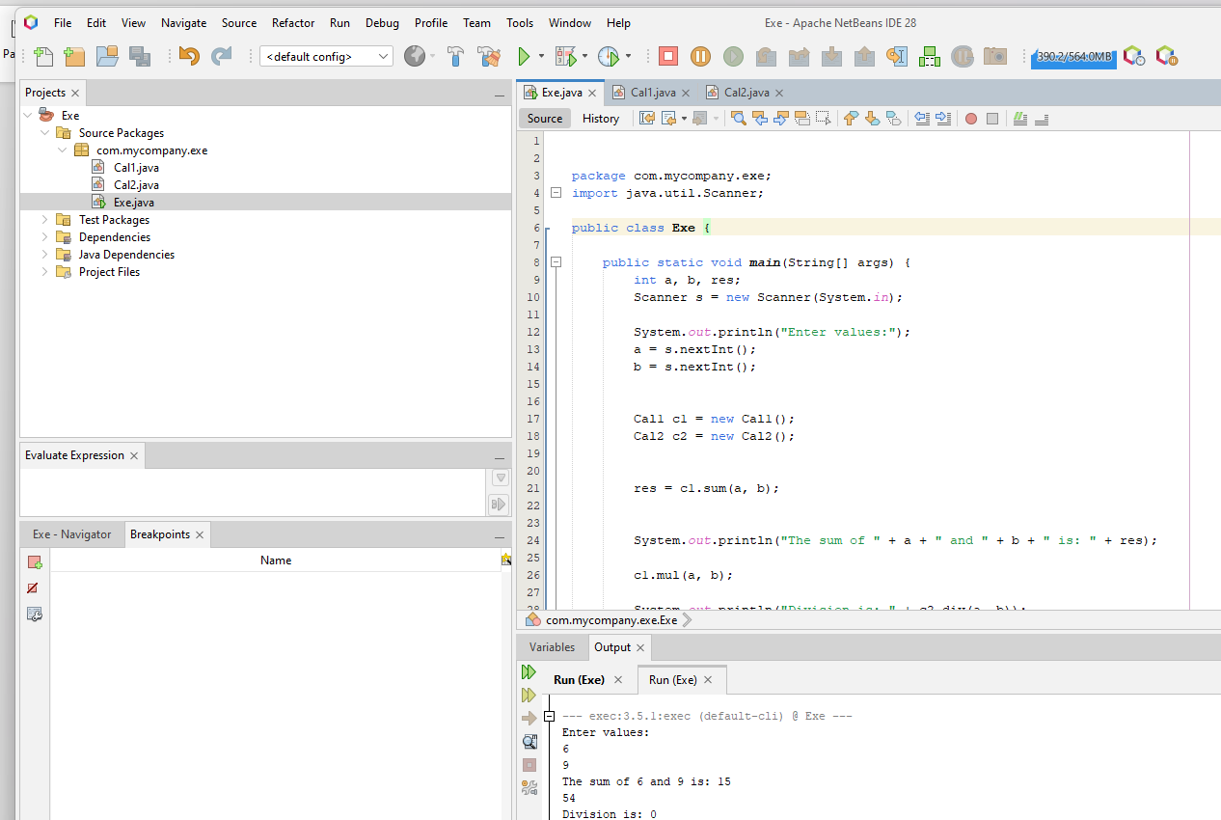

- Question 2: Make animal class and 2 other classes have name cats and dogs.Call cats and dogs feature in animal class.
- Input:
Animal Class

package com.mycompany.animal;
public class Animal {
public void sound() {
System.out.println("Animal makes a sound"); }
public static void main(String[] args) {
Animal myDog = new Dog();
Animal myCat = new Cat();
System.out.println("Testing Dog");
myDog.sound();
System.out.println("\n--- Testing Cat ---");
myCat.sound(); }
}

package com.mycompany.animal;
public class Dog extends Animal {

public void sound() {
System.out.println("Dog barks: Woof Woof!");
}
}

DOG Class

Cat Class

package com.mycompany.animal;
public class Cat extends Animal {

public void sound() {
System.out.println("Cat meows: Meow Meow!");
}
}

- Output:
Testing Dog
Dog barks: Woof Woof!

--- Testing Cat ---
Cat meows: Meow Meow!
- Lab task # 5
- Question: 1
Write a Bank Account System Stores customer information, manage bank account,
Allow deposit , Withdraw etc in java language.
- Input :
public class Bank {
public static void main(String[]args){
Customer c1 =new Customer();
c1.name= "salman";// 72387,Shan
c1.customerid = 5001;

BankAccount acc1=new BankAccount();
acc1.accountNumber =1234567;
acc1.balance= 10000;// 72387,Shan
acc1.customer =c1;

acc1.displayAccount();
acc1.deposit(2000);
acc1.withdraw(200);// 72387,Shan
acc1.displayAccount();

}

}
Bank Java

public class Customer {
String name;
int customerid;// 72387,Shan
void displayCustomer(){
System.out.println("Customer Name:"+name);
System.out.println("Customer ID:"+ customerid);// 72387,Shan
}

}
Customer Java

public class BankAccount {
int accountNumber;
double balance;// 72387,Shan
Customer customer;
void deposit(double amount){
balance = balance + amount;// 72387,Shan
System.out.println("Deposited:"+amount);
}
void withdraw (double amount){
if (amount <= balance){
balance =balance-amount;// 72387,Shan
System.out.println("Withdraw:"+amount);
} else{
System.out.println("Insufficient balance!");// 72387,Shan
} }
void displayAccount(){
customer.displayCustomer();// 72387,Shan
System.out.println("Account Number:"+ accountNumber);
System.out.println("Current Balance:"+balance);
}
}
Bank Account

run:
Customer Name:Salman
Customer ID:5001
Account Number:1234567
Current Balance:10000.0
Deposited:2000.0
Withdraw:200.0
Customer Name:Salman
Customer ID:5001
Account Number:1234567
Current Balance:11800.0
BUILD SUCCESSFUL (total time: 0 seconds)

- Question : 2
- PRIME NUMBER PROGRAM IN JAVA
- Input :
import java.util.Scanner;

public class JavaBasic {
public static void main(String[] args) { // 72387,Shan
Scanner s = new Scanner(System.in);
System.out.println("Enter Number:");
int n;
int count = 0;
n = s.nextInt();
for (int i = 1; i <= n; i++) { // 72387,Shan
if (n % i == 0) {
count++;
}
}
if (count == 2) {
System.out.println(n + " Is A Prime Number");
} else {
System.out.println(n + " Is Not A Prime Number");
}
}
}
- Output :
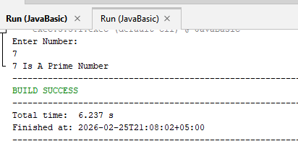

- Question : 3
- FIND LENGTH OF ARRAY
- Input :
package com.mycompany.javabasic;

public class JavaBasic { // 72387,Shan
public static void main(String[] args) {
int[] a = {1, 2, 8, 6, 9, 10}; // 72387,Shan
int length;
length = a.length;// 72387,Shan
System.out.println("Length Of Array Is: " + length);
}
}

- Output :
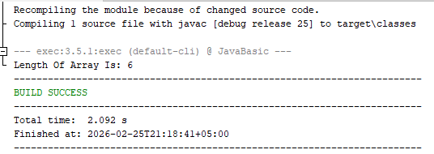

- Question : 4
- FIND THE NUMBER IS PALINDROME OR NOT
- Input :
package com.mycompany.javabasic;
import java.util.Scanner;
public class JavaBasic { // 72387,Shan
public static void main(String[] args){
Scanner s=new Scanner(System.in);
int num,temp,r=0;// 72387,Shan
System.out.println("Enter Number:");
num=s.nextInt();
temp=num;// 72387,Shan
while(num>0){
r=r*10+(num%10);
num/=10;// 72387,Shan
}
if(temp==r)
System.out.println(temp+" Is Palindrome");
else// 72387,Shan
System.out.println(temp+" Is Not Palindrome");
}
}

- Output :

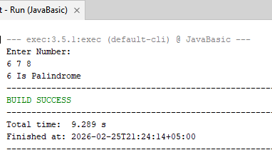
- Question : 5
- FIND FACTORIAL OF A NUMBER THROUGH FUNCTION
- Input :

import java.util.Scanner;
public class Main {
static void fact(){
Scanner s=new Scanner(System.in);// 72387,Shan
int a;
System.out.println("Enter Number For Factorial:");
a=s.nextInt();
int fact=1; // 72387,Shan
for(int i=1;i<=a;i++)
fact*=i; // 72387,Shan
System.out.println("Factorial Of "+a+" Is = "+fact);
}
public static void main(String[] args){
fact();
}
}

- Output :
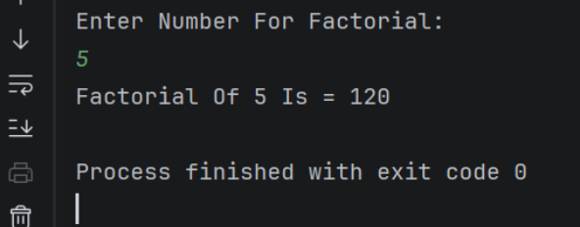

- Question : 6
SWAPPING NUMBERS USING TWO VARIABLES
- Input :
import java.util.Scanner;
public class Main {
public static void main(String[] args){
Scanner s=new Scanner(System.in);
int a,b; // 72387,Shan
System.out.println("Enter Values For Swap:");
a=s.nextInt();
b=s.nextInt();
a=a+b; // 72387,Shan
b=a-b;
a=a-b;
System.out.println("Values After Swap Are:");
System.out.println("a= "+a);
System.out.println("b= "+b);
}
}

- Output :
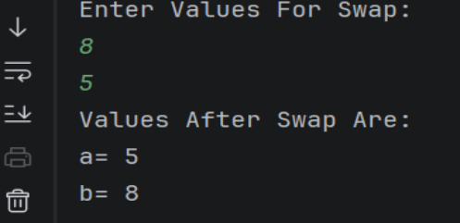

- Question : 7
SWAPPING NUMBERS USING Three VARIABLES
- Input :
import java.util.Scanner;
public class Main {
public static void main(String[] args){
Scanner s=new Scanner(System.in);
int a , b, temp; // 72387,Shan
System.out.println("Enter Values For Swap:");
a=s.nextInt();
b=s.nextInt();
temp=a; // 72387,Shan
a=b;
b=temp;
System.out.println("Values After Swap Are:");
System.out.println("a= "+a);
System.out.println("b= "+b); // 72387,Shan
}
}

- Output :
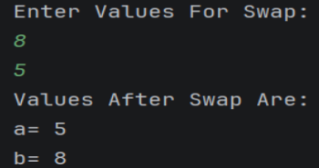

- Question : 8
RIGHT ANGLED TRIANGLE PATTERN USING NESTED LOOP
- Input :

public class Main {
public static void main(String[] args) {
for (int i = 1; i <= 5; i++) {
for (int j = 1; j <= i; j++) {
System.out.print("*"); // 72387,Shan
} // 72387,Shan
System.out.println();
}
}
}

- Output:
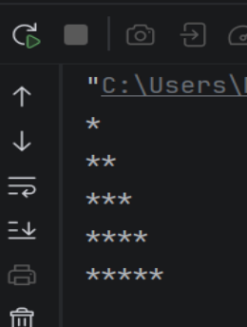

- LAB Task 6:

- Q1:Write Inheritance Code,Animal,Dog,etc.

Input

package com.mycompany.inheritanc;

//AnimalClass

class Animal {
void eat() {
System.out.println("Eating...");
}

void sleep() {
System.out.println("Sleeping...");
}
}

//DogClass

class Dog extends Animal {
void barking() {
System.out.println("Barking...");
}
}

//mainClass

public class Inheritanc {
public static void main(String[] args) {

Dog d = new Dog();
d.barking();
d.eat();
d.sleep();
}
}

Output

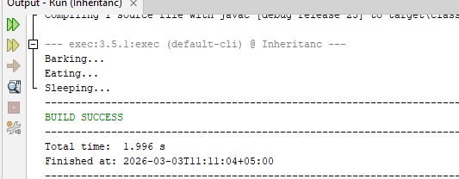

- Q2:Write Inheritance Code,Parent ,Child,Main etc.

Input

package com.mycompany.inheritanc;

// (Parent Class)
class Student {
void study() {
System.out.println("Studying basic subjects...");
}
}

// (Child Class)
class AIStudent extends Student {

void showDetails() {
System.out.println("Student Name: Shan");
System.out.println("ID: A72387");
}

void study() {
System.out.println("Studying Artificial Intelligence and C++ Programming!");
}
}

// MAIN CLASS

public class Inheritanc {
public static void main(String[] args) {

AIStudent myStudent = new AIStudent();

myStudent.showDetails();

System.out.println("--------------------");

myStudent.study();
}
}

Output
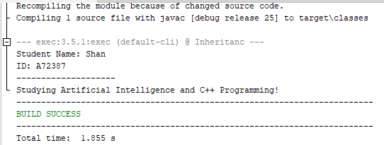

- Q3:Write Inheritance Code,Parent ,Child,Main etc.

Input

package com.mycompany.inheritanc;

// Parent Class
class Student {
void study() {
System.out.println("Studying basic subjects...");
}
void giveExam() {
System.out.println("Giving normal theory exam...");
}
}

//Child Class
class AIStudent extends Student {

void showDetails() {
System.out.println("Student Name: Shan");
System.out.println("ID: A72387");
}

void study() {
System.out.println("Studying Artificial Intelligence and C++ Programming!");
}

void giveExam() {
System.out.println("Giving AI Lab Practical Exam on NetBeans!");
}

void buildAIModel() {
System.out.println("Building a smart AI face recognition model...");
}
}

// Main Class
public class Inheritanc {
public static void main(String[] args) {

AIStudent myStudent = new AIStudent();

myStudent.showDetails();
System.out.println("--------------------");
myStudent.study();

myStudent.giveExam();
myStudent.buildAIModel();
}
}

Output
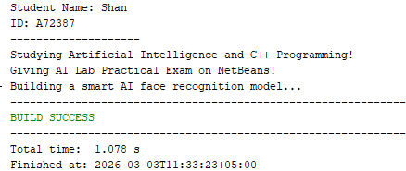

- LAB Task 7:

- Q1:Write Inheritance (Inhertical) Staff,Teacher,Accounted,etc.

Input

//Exc

package com.mycompany.staff;

public class Exc {
public static void main(String[] args) {

Teacher t = new Teacher();//Shan,72387,BSAI
t.duty();
t.strict(); //Shan,72387,BSAI
System.out.println("Shan,72387");

//Shan,72387,BSAI
Librarian l = new Librarian();
l.duty();
l.read(); //Shan,72387,BSAI
System.out.println("Shan,72387");

Accountent a = new Accountent();
a.duty();
a.fee(); //Shan,72387,BSAI
}
}

//Staff

package com.mycompany.staff;

public class Staff {
String name;//Shan,72387,BSAI
int id;

void duty() {
System.out.println("Conduct Exam");//Shan,72387,BSAI
}
}

//Teacher

package com.mycompany.staff;

//Shan,72387,BSAI
public class Teacher extends Staff {
void strict() {
System.out.println("Strict Marking");//Shan,72387,BSAI
}
}

//Librarian

package com.mycompany.staff;

//Shan,72387,BSAI
public class Librarian extends Staff {
void read() {
System.out.println("Student Read Books");//Shan,72387,BSAI
}
}

//Accountent

package com.mycompany.staff;//Shan,72387,BSAI

public class Accountent extends Staff {
void fee() {
System.out.println("Manage student dues");//Shan,72387,BSAI
}
}

Output
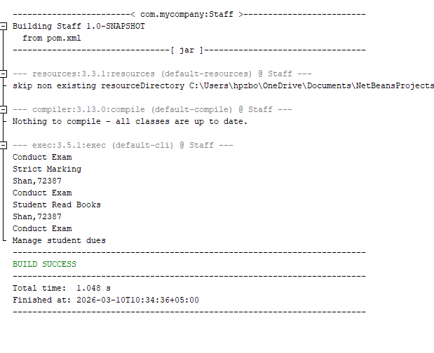

- LAB Task 8:

- Q1:Write a Java program to demonstrate Compile-time Polymorphism (Method Overloading) using a Calculator class.

Input
//Calculator Class

package com.mycompany.polymorphism;

public class Calculator {

// Shan,72387,BSAI
void sum() {
int a = 5;
int b = 6;
int c = a + b;
System.out.println("The result is " + c);
}

// Shan,72387,BSAI
void sum(int a, int b) {
int c = a + b;
System.out.println("The result is " + c);
}

// Shan,72387,BSAI
void sum(double a, int b) {
double c = a + b;
System.out.println("The result is " + c);
}

// Shan,72387,BSAI
void sum(int a, int b, int c) {
int res = a + b + c;
System.out.println("The result is " + res);
}
}

//Polymorphism(Main Class)

package com.mycompany.polymorphism;

public class Polymorphism {
public static void main(String[] args) {

int a = 10;
int b = 15;
int c = 20;

// Shan,72387,BSAI
Calculator calc = new Calculator();

// Shan,72387,BSAI
calc.sum(a, b, c); // Shan,72387,BSAI
calc.sum(2.5, 5);
calc.sum(a, b);
calc.sum(); // Shan,72387,BSAI
}
}

Output
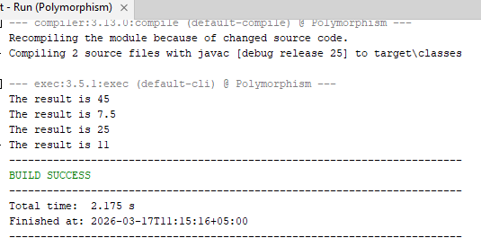

- Q2:Write a Java program to demonstrate Method Overloading. Create a Registration class with an overloaded method named enroll() that takes different student details as parameters (e.g., only name, name & ID, and name, ID & degree program). Test these methods from a main class.

Input
//Registration Class

package com.mycompany.polymorphism;

public class Registration {

// Shan,72387,BSAI
void enroll(String name) {
System.out.println("Student Name: " + name);
}

// Shan,72387,BSAI
void enroll(String name, int id) {
System.out.println("Student Name: " + name + " | ID: " + id);
}

// Shan,72387,BSAI
void enroll(String name, int id, String program) {
System.out.println("Student: " + name + " | ID: " + id + " | Program: " + program);
}
}

//MainRegistration(Main Class)

package com.mycompany.polymorphism;

public class MainRegistration {
public static void main(String[] args) {

// Shan,72387,BSAI
Registration reg = new Registration();

System.out.println("--- Registration System ---");

// Shan,72387,BSAI
reg.enroll("Shan");

// Shan,72387,BSAI
reg.enroll("Shan", 72387);

// Shan,72387,BSAI
reg.enroll("Shan", 72387, "BSAI");
}}

Output
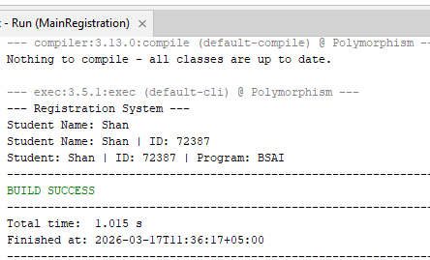

- Q3:Write a Java program to demonstrate Method Overloading. Create a Shape class with overloaded methods named calculateArea(). Implement these methods to calculate the area of a Square (takes 1 integer parameter), a Rectangle (takes 2 integer parameters), and a Circle (takes 1 double parameter). Test all methods from a main class.

Input
//Registration Class

package com.mycompany.polymorphism;

public class Shape {

// Shan,72387,BSAI
void calculateArea(int side) {
int area = side * side;
System.out.println("Area of Square is: " + area);
}

// Shan,72387,BSAI
void calculateArea(int length, int width) {
int area = length * width;
System.out.println("Area of Rectangle is: " + area);
}

// Shan,72387,BSAI
void calculateArea(double radius) {
double area = 3.14 * radius * radius;
System.out.println("Area of Circle is: " + area);
} }

//MainRegistration(Main Class)

package com.mycompany.polymorphism;

public class MainShape {
public static void main(String[] args) {

// Shan,72387,BSAI
Shape myShape = new Shape();

System.out.println("--- Area Calculator ---");

// Shan,72387,BSAI
myShape.calculateArea(5);

// Shan,72387,BSAI
myShape.calculateArea(4, 6);

// Shan,72387,BSAI
myShape.calculateArea(2.5);
}
}
Output
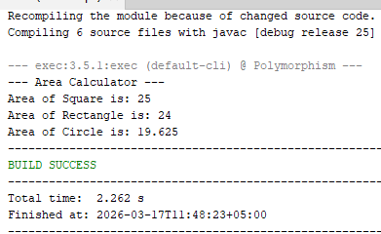

- LAB Task 9
- Write a Java program in static Polymorphisms.
- Q1:Simple Program
- Input
Class EXC
package pkgstatic.polymorphism; // SHAN,72387,BSAI

public class StaticPolymorphism {

public static void main(String[] args) {
vehicle v = new vehicle();// SHAN,72387,BSAI
v.run();
} }
Class Vehicle
package pkgstatic.polymorphism;

public class vehicle {
void run(){
System.out.println("Running...."); // SHAN,72387,BSAI
} // SHAN,72387,BSAI
int run(int a){
System.out.println("Car is Running"); // SHAN,72387,BSAI
return 0;
} }

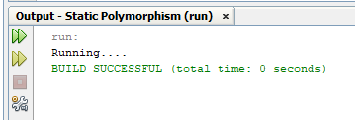

- Write a Java program in Dynamic Polymorphisms.
- Q2:Simple Program
- Input
Class EXC
package run.time;
public class RunTime {
public static void main(String[] args) {
vehicle v= new vehicle();// SHAN,72387,BSAI
v.run();
Bike b = new Bike();// SHAN,72387,BSAI
b.run();
} }
Vehicle Class
package run.time;
class vehicle {
void run(){
System.out.println("Running....."); // SHAN,72387,BSAI
} }

Bike Class
package run.time;
public class Bike {
void run(){
System.out.println("Car is running..."); // SHAN,72387,BSAI
} }

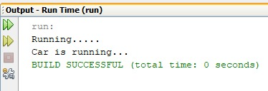

- Q2: Write a Java program to create a base class Shape with methods draw() and calculateArea(). Create two subclasses Circle and Cylinder. Override the draw() method in each subclass to draw the respective shape. In addition, override the calculateArea() method in the Cylinder subclass to calculate and return the total surface area of the cylinder.
- Input
Class Shapes
package shapes;
public class Shapes {
public void draw() {
System.out.println("Drawing a shape"); // SHAN,72387,BSAI
}
public double calculateArea() {
return 0;
} }
Class Circle
package shapes;

public class Circle extends Shapes {
double radius; // SHAN,72387,BSAI
public Circle(double radius) {
this.radius = radius; // SHAN,72387,BSAI
}
public void draw() {
System.out.println("Drawing a Circle");
}
public double calculateArea() {

return Math.PI * radius * radius; // SHAN,72387,BSAI
} }
Class Cylinder
package shapes;
public class Cylinder extends Shapes {
double radius; // SHAN,72387,BSAI
double height;
public Cylinder(double radius, double height) {
this.radius = radius; // SHAN,72387,BSAI
this.height = height;
}
public void draw() {
System.out.println("Drawing a Cylinder"); // SHAN,72387,BSAI
}
public double calculateArea() {
return 0; // SHAN,72387,BSAI
} }
Class Main
package shapes;

public class ShapesTest {

public static void main(String[] args) {
Shapes myCircle = new Circle(5.0); // SHAN,72387,BSAI
myCircle.draw();
System.out.println("Circle Area: " + myCircle.calculateArea());

System.out.println("-------------------------");// SHAN,72387,BSAI

Shapes myCylinder = new Cylinder(5.0, 10.0);
myCylinder.draw();// SHAN,72387,BSAI
System.out.println("Cylinder Surface Area: " + myCylinder.calculateArea());
} }

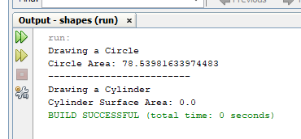

- LAB Task 10
- Q1: Polymorphism Overloading Addition Methods.
- Input
Class EXC
package com.mycompany.overloading;

import java.util.Scanner;

public class Overloading {

public static void main(String[] args) {
int a,b,c;//shan,72387,BSAI
Calculator C = new Calculator();
Scanner s= new Scanner (System.in);//shan,72387,BSAI
System.out.println("Enter values");
a=s.nextInt();
b=s.nextInt();//shan,72387,BSAI
c=s.nextInt();
int result = C.sum(a,b);//shan,72387,BSAI
System.out.println("The sum of"+a+"and"+b+"is"+result);
result = C.sum(a, b, c);//shan,72387,BSAI
System.out.println("Sum of"+a+","+b+","+c+","+result );
}
}
Class Calculator
package com.mycompany.overloading;

public class Calculator {
int sum (int a,int b,int c) {
return a+b+c;//shan,72387,BSAI
}
int sum (int a,int b){
return a+b;//shan,72387,BSAI
}
}
- Output
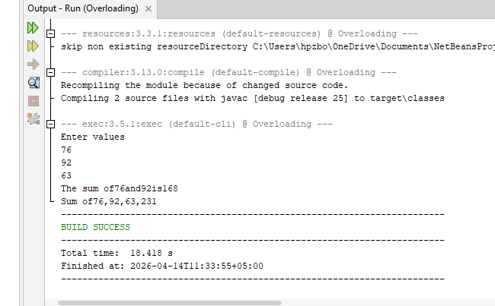

- Q2: Polymorphism Overriding,Shape,Circle,Cylinder,etc.
- Input

Class Shapes

package com.mycompany.shapes.project;
public class Shape {
void draw() {
System.out.println("Drawing a generic shape");
}
double calculateArea() {
System.out.println("Calculating Generic Area...");//shan,72387,BSAI
return 0;
}
}
Class Circle

package com.mycompany.shapes.project;
public class Circle extends Shape {
void draw() {
System.out.println("Drawing a Circle");//shan,72387,BSAI
}
}
Class Cylinder

public Cylinder(double r, double h) {
this.radius = r;
this.height = h;//shan,72387,BSAI
}
double calculateArea() {
double area = (2 * Math.PI * radius * height) + (2 * Math.PI * radius * radius);
return area;//shan,72387,BSAI
} }

Class Main

package com.mycompany.shapes.project;
import java.util.Scanner;
public class ShapesProject {
public static void main(String[] args) {
Scanner s = new Scanner(System.in);
Circle c = new Circle();//shan,72387,BSAI
c.draw();
System.out.print("Enter radius for Cylinder: ");
double r = s.nextDouble(); //shan,72387,BSAI
System.out.print("Enter height for Cylinder: ");
double h = s.nextDouble(); //shan,72387,BSAI
Cylinder cyl = new Cylinder(r, h); //shan,72387,BSAI
System.out.println("Cylinder Surface Area is: " + cyl.calculateArea());
} }
- Output

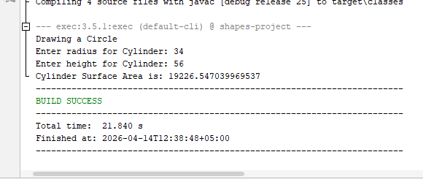

- Q3:Write a Java program to create a base class BankAccount with methods deposit() and withdraw(). Create two subclasses SavingsAccount and CheckingAccount. Override the withdraw() method in each subclass to impose different withdrawal limits and fees.
- Input
Class bankaccounts
package com.mycompany.bankaccount;
public class bankaccounts {
double balance = 1000;//shan,72387,BSAI
void deposit(double amount) {
balance = balance + amount;//shan,72387,BSAI
System.out.println("Balance: " + balance);
}
void withdraw(double amount) {
System.out.println("Withdraw from BankAccount");//shan,72387,BSAI
} }
Class SavingAccount
package com.mycompany.bankaccount;
public class SavingsAccount {
void withdraw(double amount) {
if (amount > 500) {
System.out.println("Limit exceeded");//shan,72387,BSAI
} else {
double balance = 0;
balance = balance - amount;//shan,72387,BSAI
System.out.println("Savings Balance: " + balance);
} } }

Class CheckingAccount

package com.mycompany.bankaccount;
public class CheckingAccount {
void withdraw(double amount) {
double balance = balance - amount - 10; //shan,72387,BSAI
System.out.println("Checking Balance: " + balance);
}
}

Class BankAccount(Main)

package com.mycompany.bankaccount;

public class BankAccount {

public static void main(String[] args) {

System.out.println("Testing Savings Account ");
SavingsAccount s = new SavingsAccount();//shan,72387,BSAI
s.deposit(1639);
s.withdraw(728); //shan,72387,BSAI

System.out.println("Testing Checking Account ");
CheckingAccount c = new CheckingAccount();
c.deposit(826);
c.withdraw(452); //shan,72387,BSAI
}
}

- Output

Balance: 1200
Savings Balance: 900
Balance: 1200
Checking Balance: 890

- LAB Task 11

Sir Not Conduct Class
Output
Class PostPoned
Etc………

- LAB Task 12
- Q1: Abstartion Code Simple.
- Input

- Students.java

package com.mycompany.graduatestudents;

public abstract class Students {

abstract void grade();

void show() {
System.out.println("Shan is student");
}
}

- GraduateStudents.java

package com.mycompany.graduatestudents;

public class GraduateStudents extends Students {

void grade() {
System.out.println(".....Grading......");
}

public static void main(String[] args) {

Students s = new GraduateStudents();

s.grade();
s.show();
}
}

- Output
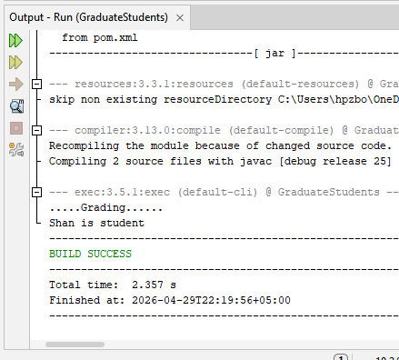

- Q2: Write a Java program to create an abstract class Employee with abstract methods calculateSalary() and displayInfo(). Create subclasses Manager and Programmer that extend the Employee class and implement the respective methods to calculate salary and display information for each role.
- Input
- Employee.java
package com.mycompany.employeeproject;
public abstract class Employee {
abstract void displayInfo();
abstract void calculateSalary();
}
- Manager.java
package com.mycompany.employeeproject;
public class Manager extends Employee {
void displayInfo() {
System.out.println("--- Manager Info ---");
System.out.println("Name : Shan");
System.out.println("ID : 72387");
}
void calculateSalary() {
double baseSalary = 150000;
double bonus = 30000;
double totalSalary = baseSalary + bonus;
System.out.println("Salary : " + totalSalary);
}
}
- Programmer.java
package com.mycompany.employeeproject;
public class Programmer extends Employee {
void displayInfo() {
System.out.println("--- Programmer Info ---");
System.out.println("Name : Saman&Shahri");
System.out.println("ID : 54326");
}
void calculateSalary() {
double hourlyRate = 500;
double hoursWorked = 200;
double totalSalary = hourlyRate * hoursWorked;
System.out.println("Salary : " + totalSalary);
}
}
- EmployeeProject.java
package com.mycompany.employeeproject;
public class EmployeeProject {
public static void main(String[] args) {
Employee m = new Manager();
m.displayInfo();
m.calculateSalary();
System.out.println();
Employee p = new Programmer();
p.displayInfo();
p.calculateSalary();
}
}

- Output
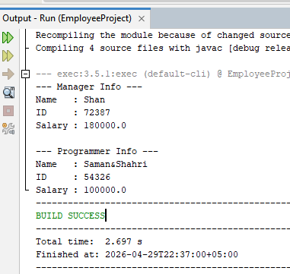

- Q3: Write a Java program to create an abstract class BankAccount with abstract methods deposit() and withdraw(). Create subclasses: SavingsAccount and CurrentAccount that extend the BankAccount class and implement the respective methods to handle deposits and withdrawals for each account type.
- Input
- BankAccount.java
package com.mycompany.bankproject;
public abstract class BankAccount {
abstract void deposit(double amount);
abstract void withdraw(double amount);
}

- SavingsAccount.java

package com.mycompany.bankproject;

public class SavingsAccount extends BankAccount {

String accountHolder = "Shan";

int accountNumber = 72387;

double balance = 50000;

double minimumBalance = 10000;

void displayInfo() {

System.out.println("====== Savings Account ======");

System.out.println("Name : " + accountHolder);

System.out.println("Account No : " + accountNumber);

System.out.println("Minimum Balance : " + minimumBalance);

System.out.println("Current Balance : " + balance);

}

void deposit(double amount) {

balance = balance + amount;

System.out.println("Savings Deposit : +" + amount);

System.out.println("Current Balance : " + balance);

}

void withdraw(double amount) {

if (balance - amount < minimumBalance) {

System.out.println("Withdrawal FAILED! Minimum balance " + minimumBalance + " rehna zaroori hai.");

} else {

balance = balance - amount;

System.out.println("Savings Withdrawal : -" + amount);

System.out.println("Current Balance : " + balance);

}

}

}

CurrentAccount.java
package com.mycompany.bankproject;
public class CurrentAccount extends BankAccount {
String accountHolder = "Global Link Traders";
int accountNumber = 10001;
double balance = 20000;
double overdraftLimit = 15000;
void displayInfo() {
System.out.println("====== Current Account ======");
System.out.println("Name : " + accountHolder);
System.out.println("Account No : " + accountNumber);
System.out.println("Overdraft Limit : " + overdraftLimit);
System.out.println("Current Balance : " + balance);
}
void deposit(double amount) {
balance = balance + amount;
System.out.println("Current Deposit : +" + amount);
System.out.println("Current Balance : " + balance);
}
void withdraw(double amount) {
if (balance - amount < -overdraftLimit) {
System.out.println("Withdrawal FAILED! Overdraft limit " + overdraftLimit + " cross ho jayegi.");
} else {
balance = balance - amount;
System.out.println("Current Withdrawal : -" + amount);
System.out.println("Current Balance : " + balance);
}
}
}
- BankProject.java
package com.mycompany.bankproject;
public class BankProject {
public static void main(String[] args) {

SavingsAccount sa = new SavingsAccount();
sa.displayInfo();
System.out.println();
sa.deposit(5000);
sa.withdraw(10000);
sa.withdraw(40000);

System.out.println();
CurrentAccount ca = new CurrentAccount();
ca.displayInfo();
System.out.println();
ca.deposit(8000);
ca.withdraw(30000);
ca.withdraw(20000);
}
}

- Output

